***Insert at given position in Singly Linked List***

**Add a node after a given node: (5 steps process)**

**Approach:** We are given a pointer to a node, and the new node is inserted after the given node.

Follow the steps to add a node after a given node:

* Firstly, check if the given previous node is NULL or not.
* Then, allocate a new node and
* Assign the data to the new node
* And then make the next of new node as the next of previous node.
* Finally, move the next of the previous node as a new node.

[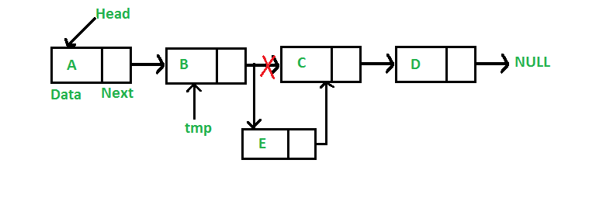](https://media.geeksforgeeks.org/wp-content/cdn-uploads/gq/2013/03/Linkedlist_insert_middle.png)

C++Java

/* This function is in LinkedList class.

Inserts a new node after the given prev_node. This method is

defined inside LinkedList class shown above */

public void insertAfter(Node prev_node, int new_data)

{

/* 1. Check if the given Node is null */

if (prev_node == null) {

System.out.println(

"The given previous node cannot be null");

return;

}

/* 2. Allocate the Node &

3. Put in the data*/

Node new_node = new Node(new_data);

/* 4. Make next of new Node as next of prev_node */

new_node.next = prev_node.next;

/* 5. make next of prev_node as new_node */

prev_node.next = new_node;

}

**Complexity Analysis:**

**Time complexity:**O(1), since prev_node is already given as argument in a method, no need to iterate over list to find prev_node  
**Auxiliary Space:**O(1) since using constant space to modify pointers